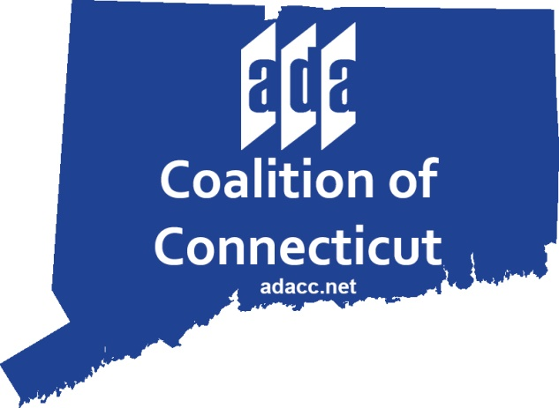

BOARD OF DIRECTORS
March 5, 2020
NEWINGTON TOWN HALL ROOM L101
131 CEDAR ST., NEWINGTON, CT
2:00 PM

AGENDA

- Call to Order
- Introductions
- Minutes of Previous Meeting
- Finance Report
- Updates from Karen Green
  - Membership
  - Google Analytics & Social Media
  - 30th Anniversary Grant Awards
  - National ADA Conference
- Updates from Dianne Stone
  - Review of New England ADA Reports
- Board Member Updates
  - Dave's Sponsorship Report
  - Carlos' Membership Report
- Other Business and Legislative Updates
- Adjournment

